Coordinate Transformations for Unsteady Frames

Kellen C. Schroeter[1]

University of Colorado, Boulder, Colorado, 80309

This report will walk through the process of transforming coordinate data through unsteady frames. To show this, an example will be followed that involves a groundstation, using a Cartesian reference frame, tracking a moving Mothership – which in turn is tracking a moving Micro Air Vehicle using the mothership’s Frenet frame. An approach to understand the movement of both vehicles from the perspective of the Groundstation will be outlined – position, velocity and acceleration vectors for both moving objects will be found.

# Nomenclature

*a* = acceleration

*α* = angular acceleration

*aN* = normal acceleration

*aT* = tangential acceleration

$\hat{b}$ = frenet binormal vector

*G* = transformation matrix

*γ* = angle of rotation of $\hat{b}$

$\hat{n}$ = frenet normal vector

*ω* = angular velocity

*φ* = angle of rotation of $\hat{t}$

r = groundstation to micro air vehicle position vector

$\overline{r}$ = mothership to micro air vehicle position vector

R = groundstation to mothership position vector

*s*= speed

*t* = time

$\hat{t}$ = frenet tangent vector

*θ* = angle of rotation of $\hat{n}$

# Overview

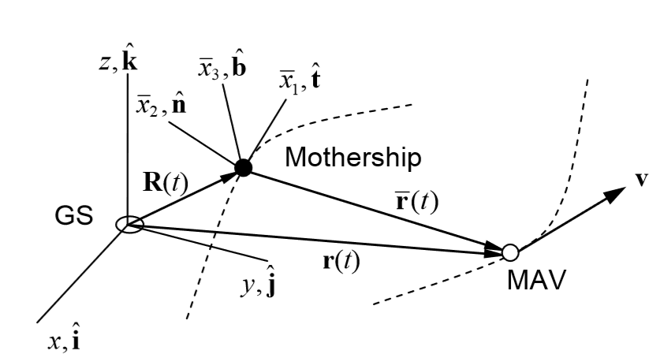

Figure 1. Coordinate Transformations for Unsteady Frames Example. *A fixed groundstation is tracking a moving mothership which is simultaneously tracking a moving micro air vehicle from a local reference frame.*

T

HE transformation of coordinates in unsteady frames has numerous practical and theoretical uses. To highlight the process for general application a functional example will be outlined. This case follows two aircraft and a groundstation and is rooted in Fig. 1. Here a Groundstation, denoted GS, serves as a global origin for the Cartesian reference frame. In this frame a Mothership, denoted MS, moves along a curve. At discrete time intervals the position of the MS is known by the GS as the vector $R$. Simultaneously, the MS is tracking a second moving object – a Micro Air Vehicle, denoted as MAV. The position of the MAV is $\overline{r}$ and is known by the MS at discrete time intervals. The position of the MAV is tracked according to a local, moving, frame attached to the MS. In this report; the basis for this local frame will be shown, the position of the MAV will be transformed into the fixed GS Cartesian frame, and the velocities and accelerations of both moving objects will be calculated. For this example the aircraft position vectors and time domain are defined below.

$R\left(t\right)=tcos\left(t\right)\hat{i}+tsin\left(2t\right)\hat{j}+t\hat{k}$ $\overline{r}\left(t\right)=\cos\left(t\right)\hat{t}+\sin\left(2t\right)\hat{n}+cos⁡(2t)\hat{b}$ $t∈[0,2π]$

# The Frenet-Serret Frame

To track the MAV a local coordinate system is placed on the MS in the form of a Frenet-Serret frame. The basis of this frame for is constructed from the position vector’s first and second derivatives (velocity and acceleration respectively). First a unit tangent vector, $\hat{t}$, is created.

$$\hat{t}=\frac{R'}{\left\|R'\right\|}$$

Next, a vector positioned right to the tangent vector is defined – the binormal vector $\hat{b}$.

$$\hat{b}=\frac{R'×R''}{\left\|R'×R''\right\|}$$

Finally, to complete the basis a third vector $\hat{n}$, normal to the first plane created, is assigned.

$$\hat{n}=\hat{b}×\hat{t}$$

Fig. 2 shows these unit vectors at various points along $R$ and $\overline{r}$ position curves. Notice that the unit tangent vector always points in the direction of velocity, the unit normal vector is 90 degrees from $\hat{t}$, and the unit binormal vector completes the orthonormal trio.

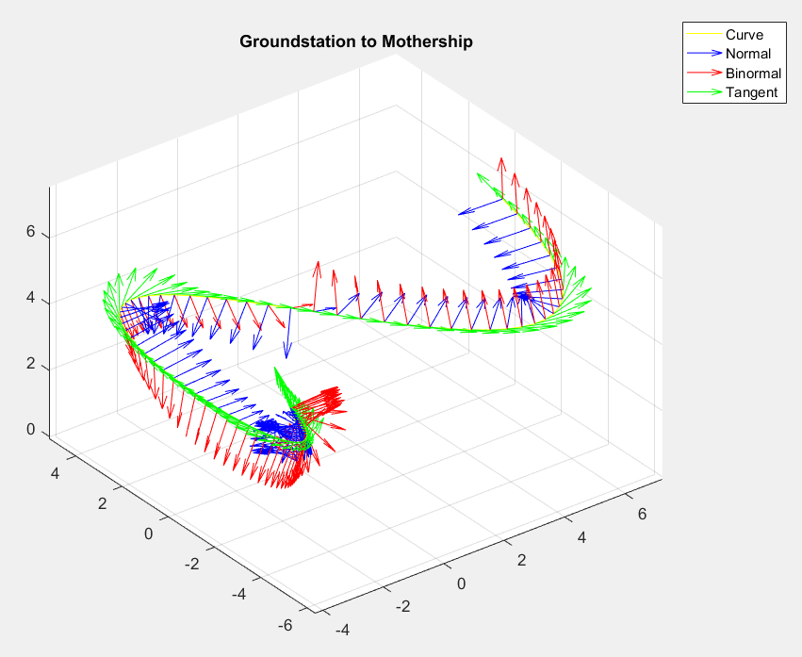 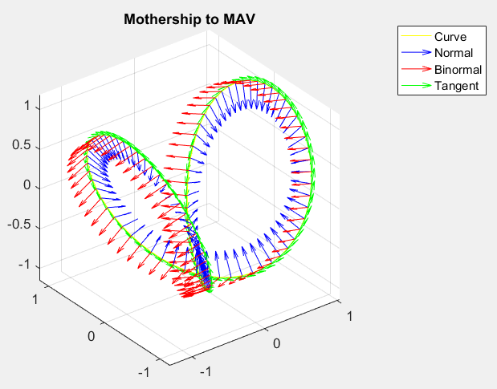

Figure 2. Frenet Frames. *Orthonormal Frenet Frames are layed over both position vectors $R$* *and $\overline{r}$*  *respectively.*

# Speed and Acceleration

Before any coordinate transformations take place, important information about the motion of the MS and MAV can still be found. First, the speed for each curve was essentially already found in the denominator of the unit tangent vector.

$s_{MS}=\left\|R'\right\|$ $s_{MAV}=\left\|\overline{r}'\right\|$

Keep in mind that $s_{MAV}$ is in the frenet frame of the MS along with the following MAV acceleration components. Next, tangential acceleration for each curve is calculated.

$a_{T_MS}=s_{MS}'$ $a_{T_MAV}=s_{MAV}'$

Finally, the normal acceleration component is found using the position vector’s derivatives.

$a_{N_MS}=\frac{\left|R'×R''\right|}{\left|R'\right|}$ $a_{N_MAV}=\frac{\left|\overline{r}'×\overline{r}''\right|}{\left|\overline{r}'\right|}$

These speed and acceleration components for the MS and MAV curves can be seen plotted in Fig.3.

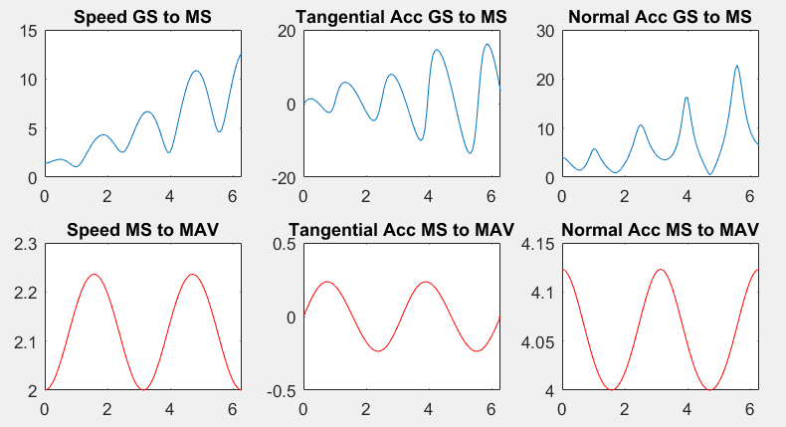

Figure 3. Speed and Acceleration Components. *Speed, tangential acceleration and normal acceleration for the MS and MAV curves - $R$*  *and $\overline{r}$*  *respectively.*

# Coordinate Transformation

Due to the transient nature of the frenet frame, its basis vectors change at each discrete time point. This fact adds some complexity to the derivation and application of the coordinate transformation. Take the frenet and Cartesian basis components as the following.

Cartesian: $\hat{i}= < 1 0 0>$ $\hat{j}= < 0 1 0>$ $\hat{k}= < 0 0 1>$

Frenet: $\hat{t}= < t_{1} t_{2} t_{3}>$ $\hat{n}= < n_{1} n_{2} n_{3}>$ $\hat{b}= < b_{1} b_{2} b_{3}>$

Thus, a matrix must be found to transform the MAV’s location from the MS’s moving frenet basis to the GS’s fixed Cartesian basis. By equating the position vectors and bases & using the definition of the moving frame it can be shown that the transformation matrix will take the following form.

$$G= \left[\begin{matrix}\hat{t}∙\hat{i} & \hat{t}∙\hat{j} & \hat{t}∙\hat{k} \\ \hat{n}∙\hat{i} & \hat{n}∙\hat{j} & \hat{n}∙\hat{k} \\ \hat{b}∙\hat{i} & \hat{b}∙\hat{j} & \hat{b}∙\hat{k}\end{matrix}\right]=\left[\begin{matrix}t_{1} & t_{2} & t_{3} \\ n_{1} & n_{2} & n_{3} \\ b_{1} & b_{2} & b_{3}\end{matrix}\right]$$

From here it the fixed-frame position vector for the MAV can simply be found at each discrete time interval.

$$r=R+G\overline{r}$$

Plotting the position of the MAV along with the position of the MS from the GS fixed frame it is easy to observe the motion of the two relative to one another. The second plot in Fig.2 shows a spiral path of motion for the MAV from the perspective of the MS. This spiral path is easy to visualize in Fig.4 where it can be more clearly observed that the MAV is still rotating around the MS – in this case a validation of a successful application of the coordinate transformation.

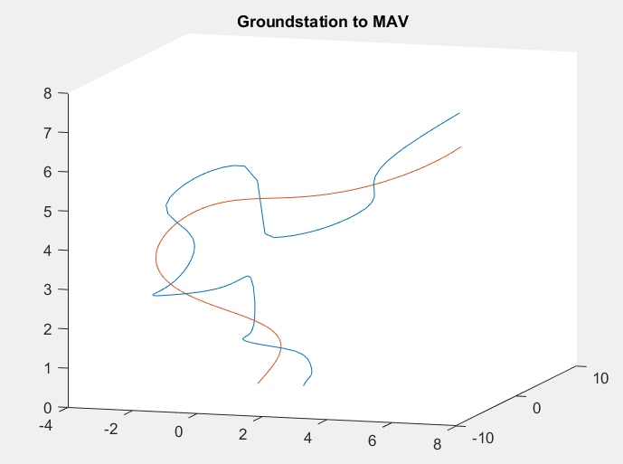

Figure 4. MAV and MS in the Cartesian Frame. *The red curve shows the flight path of the MS, the $R$ vector. The blue curve shows the transformed flight path of the MAV, the $r$ vector. Note how the r vector spirals around the R vector – a confirmation of the fig.2 plots.*

# Rotating Reference Approach to Derivatives

From this point there are two paths to find position and acceleration vectors and both will be covered. The fixed frame MAV position vector has two equivalent sides $r$ and $R+G\overline{r}$. The derivative can be taken of either side to find the velocity and acceleration vectors. First, the right side will be shown.

$$v={\left(R+G\overline{r}\right)}^{'}=R^{'}+G{\overline{r}}^{'}+ω×G\overline{r}$$

Differentiating again yields acceleration.

$$a=v^{'}=R^{''}+ G{\overline{r}}^{''}+α×r+2ω×G{\overline{r}}^{'}+ω×ω×r$$

The angular velocity term, $ω$, is the Darboux Vector and is related to the derivatives of the Frenet Frame vectors. This quantity can be found by first starting with Euler’s Angles: $φ$ is the angle of rotation of $\hat{t}$, $θ$ is the angle of rotation of $\hat{n}$, and $γ$ is the angle of rotation of $\hat{b}$.

$φ=\tan^{-1}(\frac{G_{13}}{-G_{23}})$ $θ=\tan^{-1}(\frac{\sqrt{1-{G_{33}}^{2}}}{-G_{33}})$ $γ=\tan^{-1}(\frac{G_{31}}{G_{32}})$

Next, the time derivative of each axis angle will be taken.

$\dot{φ}=\frac{dφ}{dt}$ $\dot{θ}=\frac{dθ}{dt}$ $\dot{γ}=\frac{dγ}{dt}$

Finally, the angular velocity vector can now be found.

$$ω= <\dot{φ}sinθsinγ+\dot{θ}cosγ, \dot{φ}sinθsinγ-\dot{θ}sinγ, \dot{φ}cosθ+\dot{γ}>$$

The last remaining term to complete the position derivatives is angular acceleration, $α$. This is the time derivative of angular acceleration.

$$α=\frac{dω}{dt}$$

# Direct Derivation Approach

Alternatively, the left side of the fixed-frame position vector can be used to deduce velocity, $v=\dot{r}$, and acceleration, $a=\ddot{r}$. Simply take the derivative and second derivative of the resulting position function.

$\dot{r}=\frac{dr}{dt}$ $\ddot{r}=\frac{d\dot{r}}{dt}$

In this example, both approaches have been executed and plotted in Fig. 5. Ideally, the graph sets should be completely equivalent, but there is some scaling discrepancy. By observation of expected flight paths in part iv the transformation was confirmed to be effective so the discrepancy must lie somewhere down process.

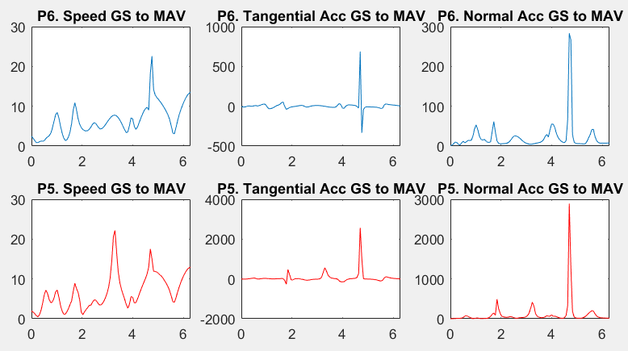

Figure 5. Velocity and Acceleration Approaches . *The blue curves show the part vi approach and the red curves show part v. General shapes are analogous but some scaling discrepancies exist.*

# Reading Data From a Text File

In the first example, MATLAB code was written to read symbolic functions for $R$ and $\overline{r}$, the computed expressions were then evaluated over a specified time domain of 0 to 2π. The code was then modified to accept text file data in a columnar form. The columns include a time vector and position values for $\overline{r}$ at each corresponding time step. These values are read, interpreted and fit to polynomial functions which are then converted to symbolic value functions. From here the solution process is carried out. This approach is computationally intensive – but it is robust and easy to navigate. Results for this approach, using the provided txt file “mav_data_txt.txt”, can be seen in Fig. 6.

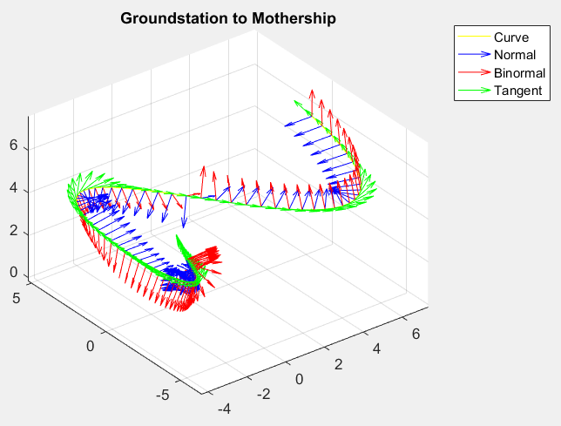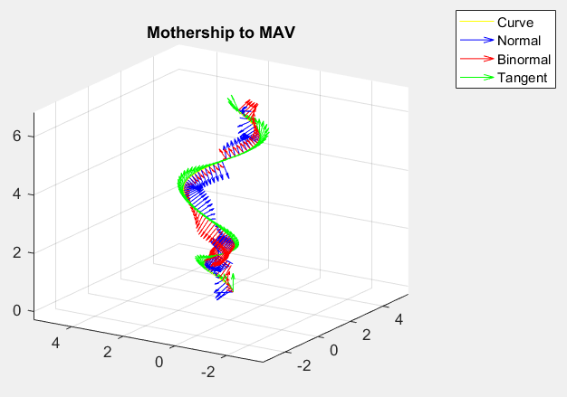

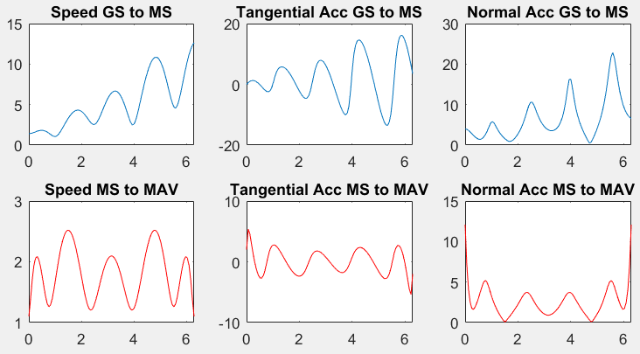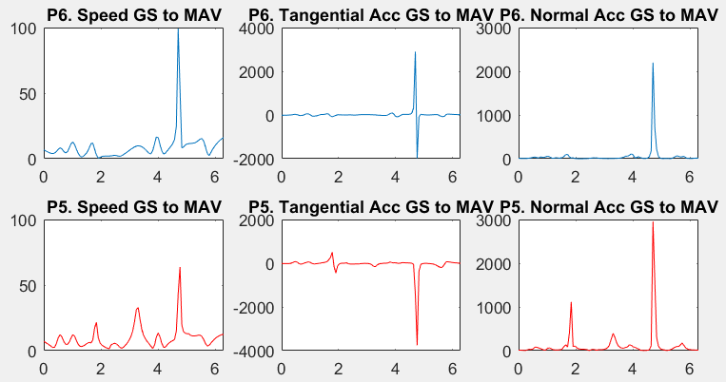

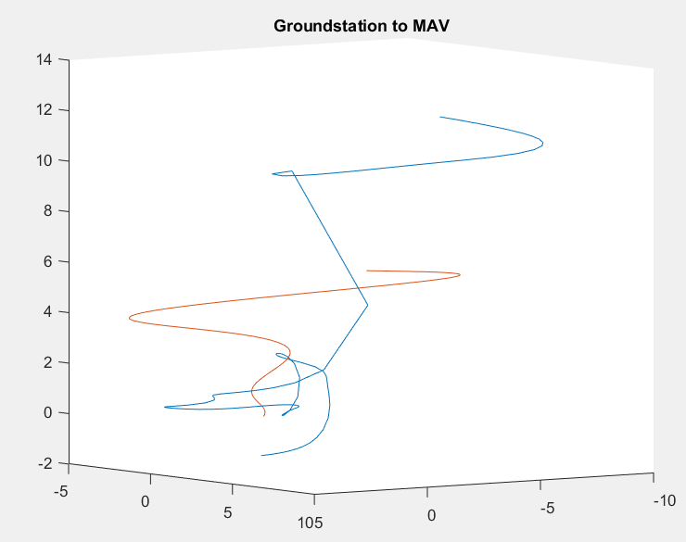

Figure 6. Reading Data From a Text File . *The top row of plots show frenet frames placed over the corresponding position vectors, similar to fig. 2. The middle row of plots show speed, normal and tangential acceleration – before and after the coordinate transformation, similar to fig. 3. The final plot shows the R vector in red and the data-driven, transformed r vector from the fixed ground station frame.*

# Appendix

Matlab m file.

*Note: switch the comment in lines 36/37 to switch from parts 1-6 to part 7.

% Kellen C. Schroeter

% University of Colorado 2016

% Course Project

%---------------------

%Set Up

tic;

clc;

clear;

close all;

syms t;

time = linspace(0,2*pi,100).';

time(1,:) = .0001;

%---Read the Text File---

Pos_read = table2array(readtable('mav_data_txt.txt'));

%convert data to symbolic function

timeread = Pos_read(:,1);

tread = Pos_read(:,2);

nread = Pos_read(:,3);

bread = Pos_read(:,1);

cvt = coeffvalues(fit(timeread,tread,'poly4'));

cvn = coeffvalues(fit(timeread,nread,'poly7'));

cvb = coeffvalues(fit(timeread,bread,'poly2'));

tb = poly2sym([cvt(1),cvt(2),cvt(3),cvt(4),cvt(5)],t);

nb = poly2sym([cvn(1),cvn(2),cvn(3),cvn(4),cvn(5),cvn(6),cvn(7),cvn(8)],t);

bb = poly2sym([cvb(1),cvb(2),cvb(3)],t);

%---Part 1---

%(a) GS to Mothership Vect

R_GStoMS = [t.*cos(t) t.*sin(2*t) t];

%(b) Mothership to MAV Vect

%Switch these comments for --P7--

R_MStoMAV = [cos(t) sin(2*t) cos(2*t)];

%R_MStoMAV = [tb nb bb];

% Derivatives

dR = diff(R_GStoMS)/diff(t);

ddR = diff(R_GStoMS,2)/diff(t);

dr_bar = diff(R_MStoMAV)/diff(t);

ddr_bar = diff(R_MStoMAV,2)/diff(t);

%---Part 2---

% Frenet Vectors

t1 = dR/norm(dR);

b1 = cross(dR,ddR)/norm(cross(dR,ddR));

n1 = cross(b1,t1);

t2 = dr_bar/norm(dr_bar);

b2 = cross(dr_bar,ddr_bar)/norm(cross(dr_bar,ddr_bar));

n2 = cross(b2,t2);

% Prep Plots

x1 = subs(R_GStoMS(1),t,time);

y1 = subs(R_GStoMS(2),t,time);

z1 = subs(R_GStoMS(3),t,time);

x2 = subs(R_MStoMAV(1),t,time);

y2 = subs(R_MStoMAV(2),t,time);

z2 = subs(R_MStoMAV(3),t,time);

t_GStoMS = subs(t1,t,time);

n_GStoMS = subs(n1,t,time);

b_GStoMS = subs(b1,t,time);

t_MStoMAV = subs(t2,t,time);

n_MStoMAV = subs(n2,t,time);

b_MStoMAV = subs(b2,t,time);

% Requested Plots

figure

plot3(x1,y1,z1,'color','y'),hold on

title('Groundstation to Mothership')

quiver3(x1,y1,z1,n_GStoMS(:,1),n_GStoMS(:,2),n_GStoMS(:,3),'color','b'),hold on

quiver3(x1,y1,z1,b_GStoMS(:,1),b_GStoMS(:,2),b_GStoMS(:,3),'color','r'),hold on

quiver3(x1,y1,z1,t_GStoMS(:,1),t_GStoMS(:,2),t_GStoMS(:,3),'color','g'),hold on

grid,daspect([1 1 1]),axis vis3d

legend('Curve','Normal','Binormal','Tangent')

figure

plot3(x2,y2,z2,'color','y'),hold on

title('Mothership to MAV')

quiver3(x2,y2,z2,n_MStoMAV(:,1),n_MStoMAV(:,2),n_MStoMAV(:,3),'color','b'),hold on

quiver3(x2,y2,z2,b_MStoMAV(:,1),b_MStoMAV(:,2),b_MStoMAV(:,3),'color','r'),hold on

quiver3(x2,y2,z2,t_MStoMAV(:,1),t_MStoMAV(:,2),t_MStoMAV(:,3),'color','g'),hold on

grid,daspect([1 1 1]),axis vis3d

legend('Curve','Normal','Binormal','Tangent')

%---Part 3---

speed1 = norm(dR);

speed2 = norm(dr_bar);

at1 = dot(ddR,dR)/norm(dR);

at2 = dot(ddr_bar,dr_bar)/norm(dr_bar);

an1 = norm(cross(dR,ddR))/norm(dR);

an2 = norm(cross(dr_bar,ddr_bar))/norm(dr_bar);

s_GStoMS = subs(speed1,t,time);

s_MStoMAV = subs(speed2,t,time);

at_GStoMS = subs(at1,t,time);

at_MStoMAV = subs(at2,t,time);

an_GStoMS = subs(an1,t,time);

an_MStoMAV = subs(an2,t,time);

figure

subplot(2,3,1)

plot(time,s_GStoMS)

xlim([0,2*pi])

title('Speed GS to MS')

subplot(2,3,2)

plot(time,at_GStoMS)

xlim([0,2*pi])

title('Tangential Acc GS to MS')

subplot(2,3,3)

plot(time,an_GStoMS)

xlim([0,2*pi])

title('Normal Acc GS to MS')

subplot(2,3,4)

plot(time,s_MStoMAV,'color','r')

xlim([0,2*pi])

title('Speed MS to MAV')

subplot(2,3,5)

plot(time,at_MStoMAV,'color','r')

xlim([0,2*pi])

title('Tangential Acc MS to MAV')

subplot(2,3,6)

plot(time,an_MStoMAV,'color','r')

xlim([0,2*pi])

title('Normal Acc MS to MAV')

%---Part 4---

% Transformation Vector

G = [t1(1) t1(2) t1(3);

n1(1) n1(2) n1(3);

b1(1) b1(2) b1(3)];

% GS to MAV Vector

r = R_GStoMS + (G*R_MStoMAV')';

% Euler Angles

phi = atan(G(1,3)/-G(2,3));

theta = atan(sqrt(1-(G(3,3)^2))/G(3,3));

psi = atan(G(3,1)/G(3,2));

phid = diff(phi)/diff(t);

thetad = diff(theta)/diff(t);

psid = diff(psi)/diff(t);

wbf = [phid*sin(theta)*sin(psi)+thetad*cos(psi) phid*sin(theta)*cos(psi)-thetad*sin(psi) (phid*cos(theta)+psid)];

win = [psid*sin(theta)*sin(phi)+thetad*cos(phi) -psid*sin(theta)*cos(phi)+thetad*sin(phi) (psid*cos(theta)+phid)];

w = wbf;

alpha = diff(w)/diff(t);

%---Part 5---

v = dR + (G*dr_bar')' + cross(w,(G*R_MStoMAV')');

a = ddR + (G*ddr_bar')' + cross(alpha,r) + cross(2*w,(G*dr_bar')') + cross(w,cross(w,r));

%---Part 6---

dr = diff(r)/diff(t);

ddr = diff(dr)/diff(t);

% Part 5&6 Comparison Plots

rVect = feval(matlabFunction(r),time);

rVelo = feval(matlabFunction(dr),time);

rdot = feval(matlabFunction(v),time);

% Speed, Normal&Tangential Acceleration Comparisons

speed3 = norm(dr);

speed4 = norm(v);

rAcc = feval(matlabFunction(ddr),time);

rdubdot = feval(matlabFunction(a),time);

at3 = dot(ddr,dr)/norm(dr);

at4 = dot(a,v)/norm(v);

an3 = norm(cross(dr,ddr))/norm(dr);

an4 = norm(cross(v,a))/norm(v);

% Plot Prep

s_GStoMAV1 = feval(matlabFunction(speed3),time);

s_GStoMAV2 = feval(matlabFunction(speed4),time);

at_GStoMAV1 =feval(matlabFunction(at3),time);

at_GStoMAV2 = feval(matlabFunction(at4),time);

an_GStoMAV1 = feval(matlabFunction(an3),time);

an_GStoMAV2 = feval(matlabFunction(an4),time);

% Plot

hold on

figure

subplot(2,3,1)

plot(time,s_GStoMAV1)

xlim([0,2*pi])

title('P6. Speed GS to MAV')

subplot(2,3,2)

plot(time,at_GStoMAV1)

xlim([0,2*pi])

title('P6. Tangential Acc GS to MAV')

subplot(2,3,3)

plot(time,an_GStoMAV1)

xlim([0,2*pi])

title('P6. Normal Acc GS to MAV')

subplot(2,3,4)

plot(time,s_GStoMAV2,'color','r')

xlim([0,2*pi])

title('P5. Speed GS to MAV')

subplot(2,3,5)

plot(time,at_GStoMAV2,'color','r')

xlim([0,2*pi])

title('P5. Tangential Acc GS to MAV')

subplot(2,3,6)

plot(time,an_GStoMAV2,'color','r')

xlim([0,2*pi])

title('P5. Normal Acc GS to MAV')

figure

hold on

plot3(rVect(:,1), rVect(:,2), rVect(:,3))

hold on

plot3(x1, y1, z1)

title('Groundstation to MAV')

figure

hold on

plot3(rVelo(:,1), rVelo(:,2), rVelo(:,3))

hold on

plot3(rdot(:,1), rdot(:,2), rdot(:,3))

legend('part 5 velocity','part 6 velocity')

title('MAV Velocity from GS')

figure

hold on

plot3(rAcc(:,1), rAcc(:,2), rAcc(:,3))

hold on

plot3(rdubdot(:,1), rdubdot(:,2), rdubdot(:,3))

legend('part 5 acc','part 6 acc')

title('MAV Acceleration from GS')

# Acknowledgments

Thanks to Dr. Hussein for coordinating a great class and to Hossein for great communication and help through out the semester!

1. Student, Aerospace Engineering Sciences